**DID YOU KNOW THE EMPLOYEE ASSISTANCE PROGRAM COVERS ALL THIS AND MORE?**

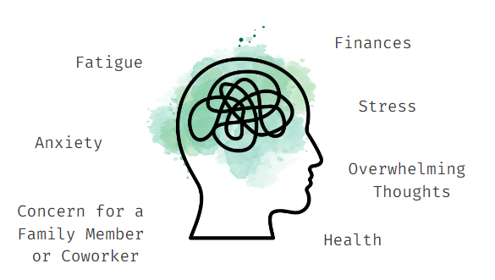

**Don’t wait for crisis mode.**

**(XXX) XXX - XXXX**

**QR CODE TO EAP SITE**

**EMAIL ADDRESS**

**DON’T WAIT FOR CRISIS MODE.**



**Use the Employee Assistance Program any time.**

**(XXX) XXX - XXXX**

**QR CODE TO EAP SITE**

**EMAIL ADDRESS**